E-biking for the whole family!
Backed by an OxLEP grant, Cotswold Electric Bike Tours is launching a fleet of powerful Tern e-cargo bikes for the 2023 season to bring our exciting e-biking experiences to new audiences. Now children, and some adults previously unable participate, perhaps because of disability or age restrictions*, can join in the fun on these adaptable cargo bikes.
*The minimum age for riding e-bikes on public roads in the UK is 14 years.
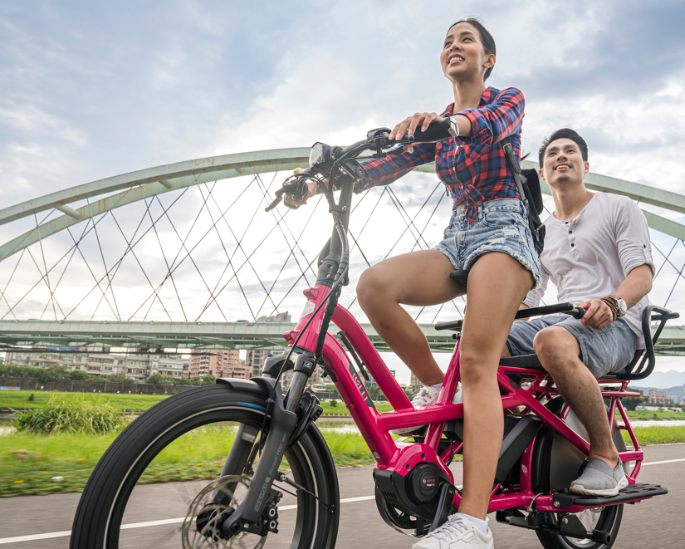
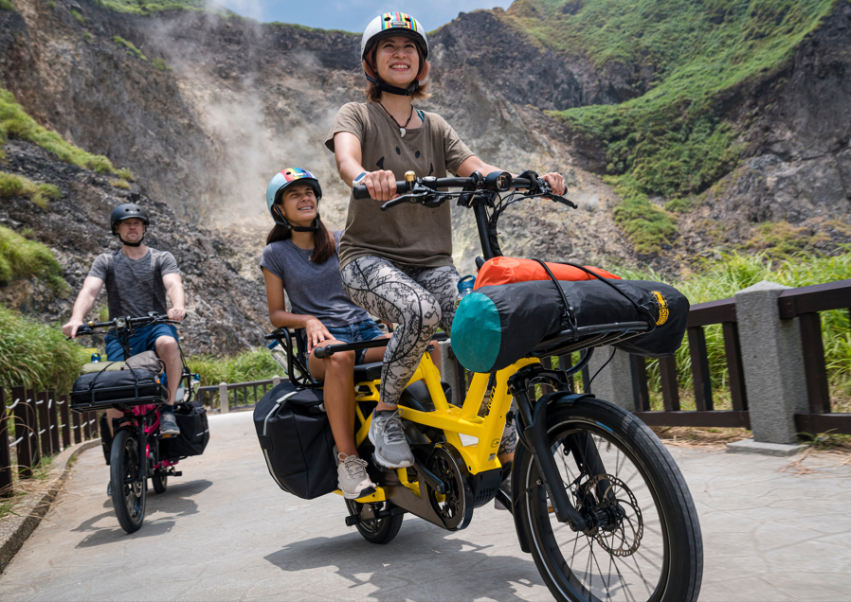
Having pioneered e-biking in the Cotswolds with popular guided tours and self-guided holidays, families can now enjoy this greener, cleaner and fun way to experience perhaps the most perfectly preserved area of England. In addition to the partnerships we’ve developed with local hospitality trade, we’ve now forged links to create some great camping/glamping holidays in the Cotswolds accessible by train.
With specially developed Bosch Cargo-Line motors and a low centre of gravity, these class-leading e-cargo bikes are a great way to get you, your family and your kit around the beautiful without a car.
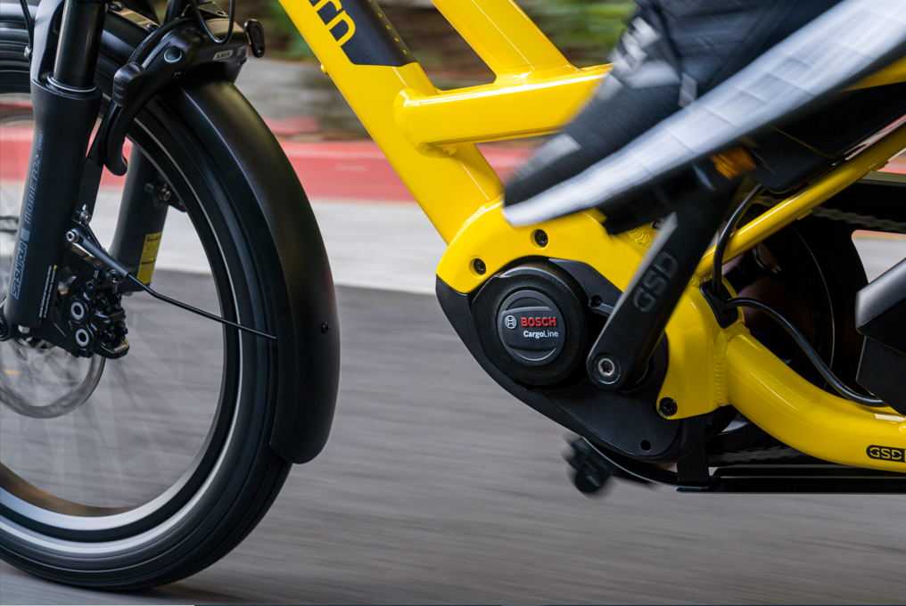
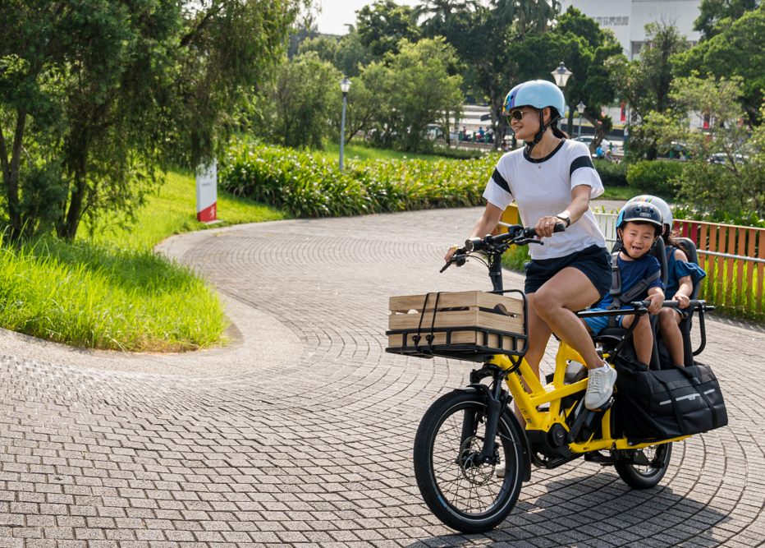
Photos courtesy of Tern

